A

PROJECT REPORT

ON

**DIGITAL CONTACTBOOK**

Towards partial fulfillment of the requirement in

**2nd Semester** **BCA 2020-21**

**Submitted By: -**

200510101167 Varunkumar Singh

200510101161 Digpal Singh

200510101163 Madhav Singh

**Submitted To: -**



**Parul Institute of Computer Application,**

**Parul University.**

Under the Guidance of

Prof. Dharmendrasinh Rathod (Assistant Professor)

**Acknowledgement**

*The success and final outcome of this project required a lot of guidance and assistance from many people and we are extremely privileged to have got this all along the completion of our project. All that we have done is only due to such supervision and assistance and we would not forget to thank them.*

*I respect and thank Dr. Priya Swaminarayan, Dean, FITCS for providing us an opportunity to do the project work in BCA and giving us all support and guidance, which made us complete the project duly. We are extremely thankful to Mam for providing her support and guidance, although she had busy schedule managing the academic affairs.*

*We would not forget to remember Prof. Hina Chokshi, HOD, BCA department for her encouragement and more over for her timely support and guidance till the completion of our project work.*

*We owe our deep gratitude to our project guide Prof. Dharmendrasinh Rathod who took keen interest on our project work and guided us all along, till the completion of our project work by providing all the necessary information for developing a good system.*

*I am thankful to and fortunate enough to get constant encouragement, support and guidance from our Parents, all Teaching staffs of BCA Department which helped us in successfully completing our project work. Also, we would like to extend our sincere esteems to all staff in laboratory for their timely support.*

***[Varunkumar Singh] [200510101167]***

***[Digpal Singh] [200510101161]***

***[Madhav Singh] [200510101163]***



**PARUL INSTITUTE OF COMPUTER APPLICATION**

**CERTIFICATE**

This is to certify that ***Varunkumar Singh, Digpal Singh and Madhav Singh*** the student(s) of Parul Institute of Computer Application, has/have satisfactorily completed the project entitled ***“________Digital Contact Book__________”*** as a part of course curriculum in BCA/B.Sc. IT/IMCA semester-II for the academic year 2020-2021 under guidance of ***Prof Dharmendrasinh*** Rathod***.***

Enrollment Number: 200510101167

Enrollment Number: 200510101161

Enrollment Number: 200510101163

|  |  |  |
| --- | --- | --- |
| **Quality of work** | **Grade** | **Sign of Internal guide** |
| **Poor / Average / Good /**  **Excellent** | **B /B+ / A / A+** |  |

Date of submission:

HOD, Principal,

Prof. Hina Chokshi Dr. Priya Swaminarayan

**INDEX**

|  |
| --- |
| **Content** **Page No.** |
| 1. Introduction to Project System 6 |
| 1. System Requirement Specification 7-9 |
| * 1. Introduction to SRS |
| * 1. Hardware Requirement |
| * 1. Software Requirement |
| * 1. System Users |
| * 1. Description of User Role |
| * 1. System Features |
| * 1. Description of Features |
| * 1. Timeline Chart |
| 1. System Flow Diagram 10 |
| 1. Data Dictionary 11 |
| 1. Screenshots of Development Phase -1 13 |
| 1. Screenshots of Development Phase -2 14 |
| 1. Screenshots of Development Phase -3 15 |
| 1. Conclusion 16 |
| 1. Future Enhancement 17 |
| 1. References 18 |

**ABSTRACT**

Digital contact book is a small python application developed has a mini project. In older days we stored our Important contact details in books and papers. Here we proposed a new system, by using this application we can store all the details in a central repository.

In manual method if we forget our physical contact book then it is very difficult to get the contact details. By using this application, we can see our contacts from digital platforms. Digital Platforms are highly efficient. There are many functionalities which digital contact books have and physical contact books don’t have. Digital contact book consists of many features and give user flexibility to use it has he wants it to work. User can add contacts without any efforts he can view existing contacts delete contacts edit existing contacts or if he wants, he can reset all contacts if he wants to and only emergency contact numbers will remain.

**Chapter 1**

**Introduction to Project System**

Digital Contact Book is a project that provides us technical help. We have Created a simple Python based solution to store our contacts. We can use it to replace our hard contact books or even use it as an office wide phone directory. This will help user to easily search and manage contacts using this system. The admin will have the authority to add and delete as well as modify the existing records within the phone book directory.

There are many functionalities which digital contact books have and physical contact books don’t have. Digital contact book consists of many features and give user flexibility to use it has he wants it to work. User can add contacts without any efforts he can view existing contacts delete contacts edit existing contacts or if he wants, he can reset all contacts if he wants to and only emergency contact numbers will remain.

A Digital contact book is a small python application developed has a mini project. In older days we stored our Important contact details in books and papers. Here we proposed a new system, by using the application we can store all the details in a central repository. In manual method if we forget our physical contact book then it is very difficult to get the contact details. By using this application, we can see our contacts from digital platforms. Digital Platforms are highly efficient and more convenient.

The project is directed towards individual users. Only the user will be able to access the data at any moment the user will have the ability to add id and password and use it to access the interface of the program hence it is secure and user friendly. The program has a clean interface which the user can understand very easily with minimal training.

**Chapter 2**

**System Requirement Specification**

**2.1 Introduction to SRS**

**2.1.1 What is SRS?**

A software requirements specification (SRS) is a description of a software system to be developed. It lays out functional and non-functional requirements, and may include a set of use cases that describe user interactions that the software must provide.

**2.1.2 Need of SRS**

In order to fully understand one’s project, it is very important that they come up with a SRS listing out their requirements, how are they going to meet it and how will they complete the project. It helps the team to save upon their time as they are able to comprehend how are going to go about the project. Doing this also enables the team to find out about the limitations and risks early on.

**2.2 Hardware Requirement**

|  |  |
| --- | --- |
| **Hardware Components** | **Specification** |
| Processor | Intel core I3, /I5 |
| RAM | 4GB/8GB |
| Hard disk | 512GB/1TB |
| Monitor | 15.6 colour monitor or advance |
| Device | Keyboard, Mouse |

**2.3 Software Requirement**

**Software Requirement**

|  |  |
| --- | --- |
| **Name of component** | **Specification** |
| Operating System | Windows, windows10 |
| Software development kit | Python Version 3 or above, Python IDE/ PyCharm /VS code/ Chrome browser/ Firefox browser |
| Programming language | Python Programming |

**2.4 System Users**

2.4.1 Client

**2.5 Description of User Role**

**2.5.1 Client**

Client can login into the system.

Client can view the contacts.

Client can edit the contacts.

Client can add the contacts.

Client can delete contacts.

Client can reset directory to its default state.

**2.6 System Features**

2.6.1 Login

2.6.2 View Contacts

2.6.3 Edit Contacts

2.6.4 Add Contacts

2.6.5 Delete Contacts

2.6.6 Reset Contacts

**2.7** **Description of Features**

**2.61 Login**

The user can login the system.

**2.6.2 View Contacts**

The client can view existing contacts by clicking on it and the contact will fill

the name and phone number area.

**2.6.3 Edit Contacts**

It is used to edit existing contacts to the list.

**2.6.4 Add Contacts**

The client can add new contacts to existing list.

**2.6.5 Delete Contacts**

The client can delete existing contacts from the list.

**2.6.6 Reset Contacts**

The client can reset all contacts Fields to its default state.

**2.8 Timeline Chart**

|  |  |  |  |  |  |  |  |
| --- | --- | --- | --- | --- | --- | --- | --- |
| **Development phase** | ***75 Days*** | | | | | | **Duration**  **N**  **(days)** |
| 0to10 days | 11to20  days | 21to30 days | 31to40 days | 41to50 days | 51to75  days |
| **Requirement**  **Gathering** |  |  |  |  |  |  | 07 |
| **Analysis** |  |  |  |  |  |  | 09 |
| **Design** |  |  |  |  |  |  | 10 |
| **Development Phase 1** |  |  |  |  |  |  | 13 |
| **Development Phase 2** |  |  |  |  |  |  | 13 |
| **Development Phase 3** |  |  |  |  |  |  | 13 |
| **Documentation** |  |  |  |  |  |  | 10 |
| **Total time**  **(Days)** |  | | | | | | **75** |

2.8Time line chart of Digital Contact Book

**Chapter 3**

**System Flow Diagram**

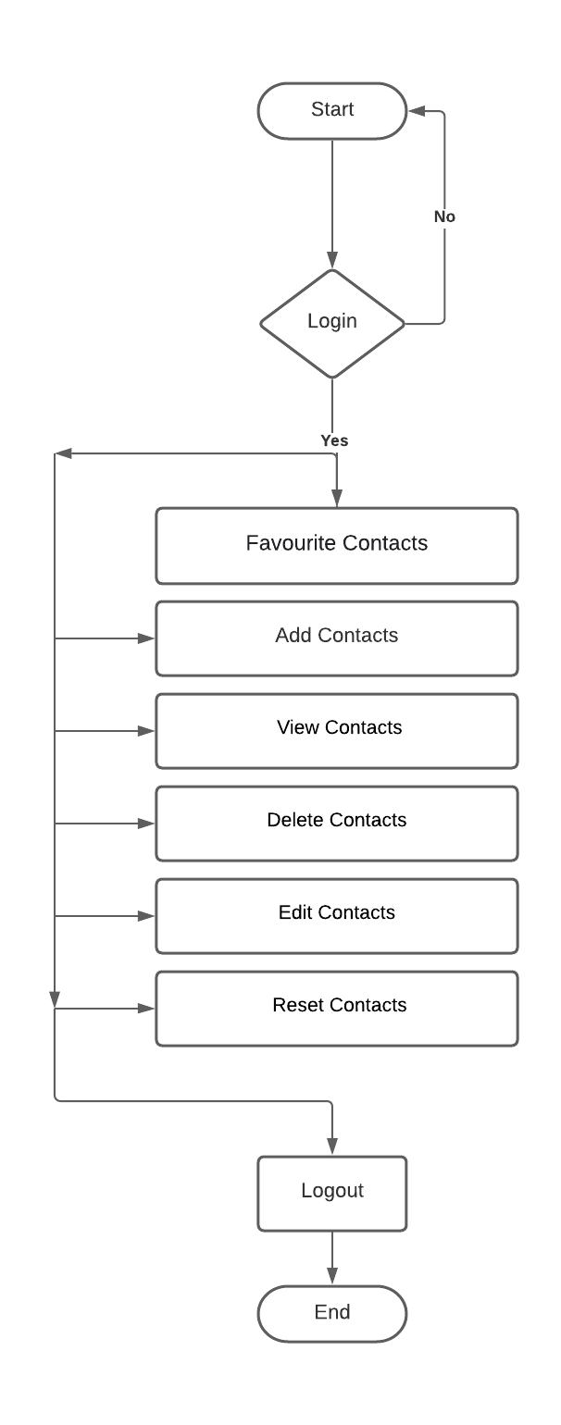

Figure 1. System Flow Diagram of Digital Contact Book

**Chapter 4**

**Data Dictionary**

**4.1 Contact Information**

View Contacts

|  |  |  |  |  |  |  |
| --- | --- | --- | --- | --- | --- | --- |
| **Sr. No.** | **Field Name** | **Data Type** | **Size** | **Constraint** | **Description** | **Example** |
| 01 | Name | Varchar | 100 | Not Null | Contact Name | Digpal Singh |
| 02 | Phone Number | Varchar | 100 | Not Null | Phone Number | 9680487642 |
| 03 | Default Contacts | Varchar | 100 | Not Null | Emergency Services | Police 100 |

4.1 Contact Information

Edit Contacts

|  |  |  |  |  |  |  |
| --- | --- | --- | --- | --- | --- | --- |
| **Sr. No.** | **Field Name** | **Data Type** | **Size** | **Constraint** | **Description** | **Example** |
| 01 | Name | Varchar | 100 | Not Null | Contact Name | Digpal Singh |
| 02 | Phone Number | Varchar | 100 | Not Null | Phone Number | 9680487642 |

4.2 Contact Information

Add Contacts

|  |  |  |  |  |  |  |
| --- | --- | --- | --- | --- | --- | --- |
| **Sr. No.** | **Field Name** | **Data Type** | **Size** | **Constraint** | **Description** | **Example** |
| 01 | Name | Varchar | 100 | Not Null | Contact Name | Digpal Singh |
| 02 | Phone Number | Varchar | 100 | Not Null | Phone Number | 9680487642 |
| 03 | Default Contacts | Varchar | 100 | Not Null | Emergency Services | Police 100 |

4.3 Contact Information

**Chapter 5**

**Screenshot of Development Phase 1**

**5.1 Digital Contact Book Design**

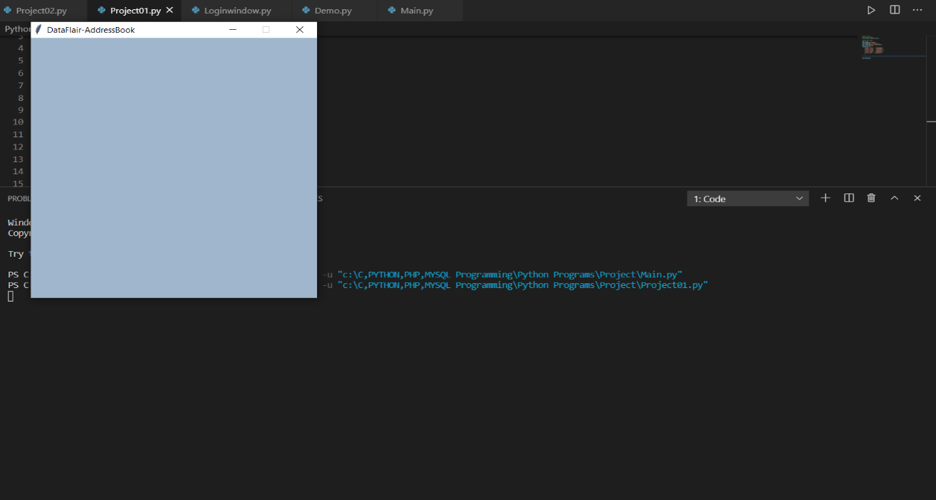

Figure 5.1 Digital Contact Book Design

**5.2Code of Digital Contact Book**

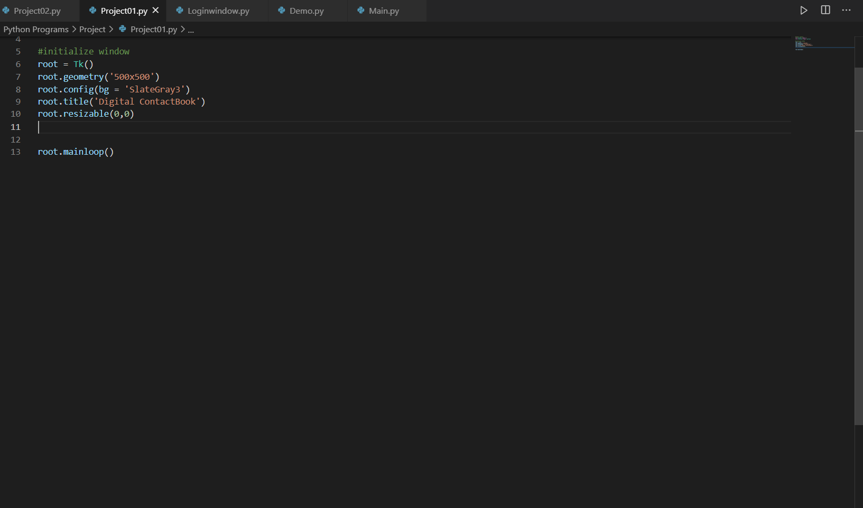

Figure 5.2 Code of Digital Contact Book

**Chapter 6**

**Screenshot of Development Phase 2**

**6.1 Digital Contact Book Design**

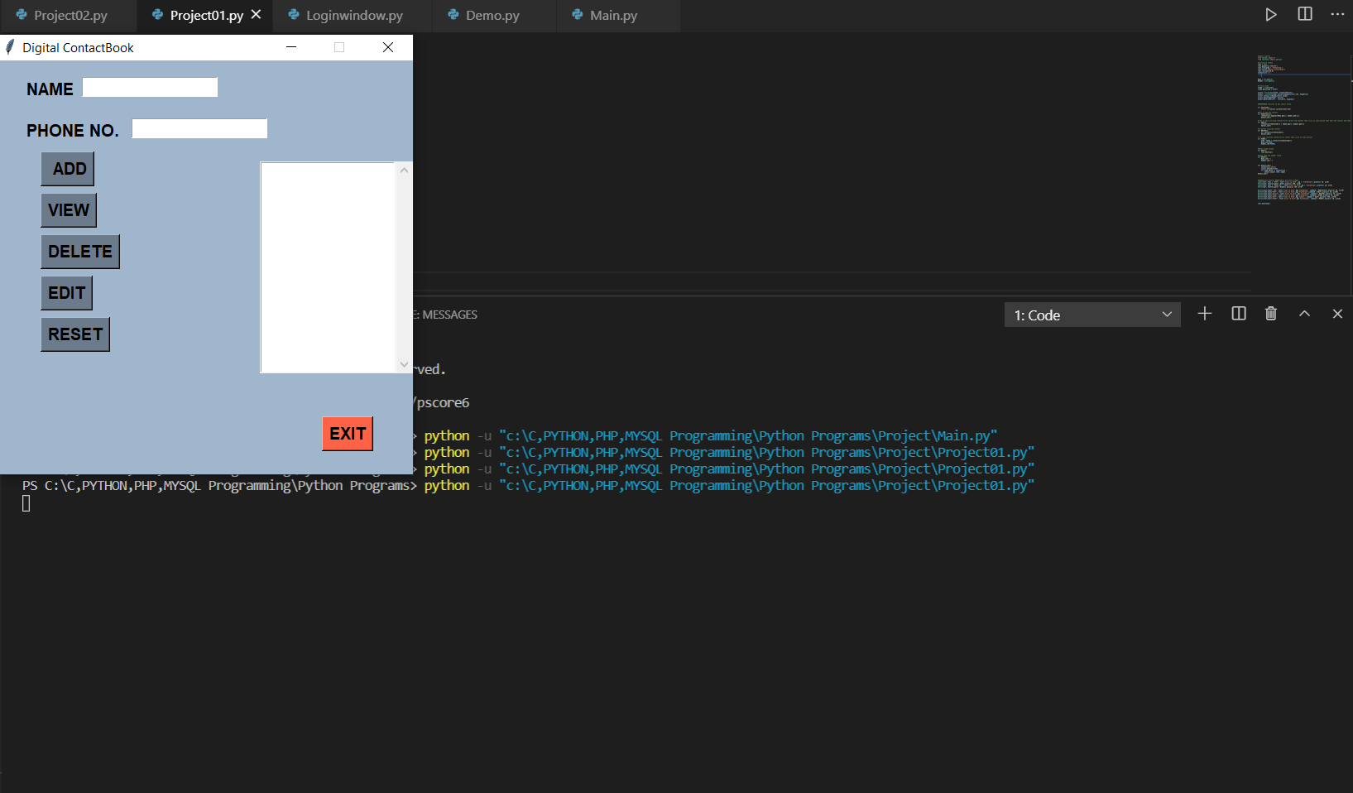

Figure 6.1 Digital Contact Book Design

**6.2Code of Digital Contact Book**

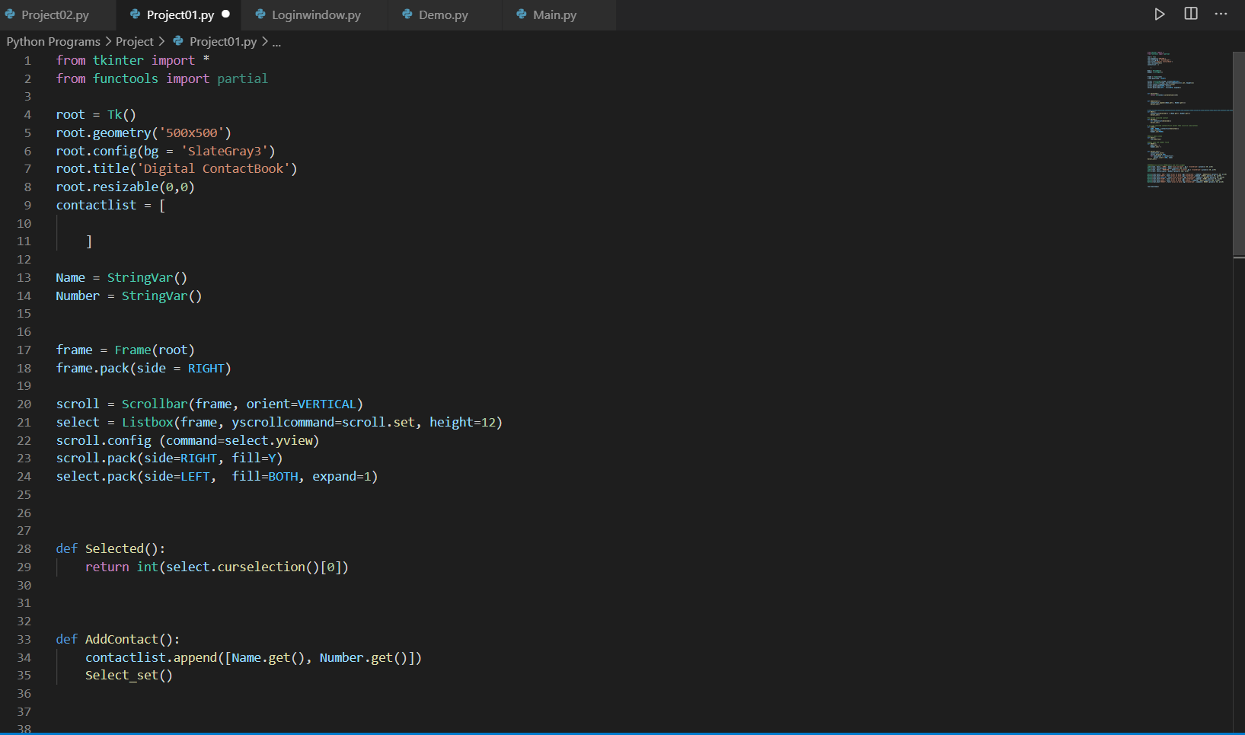

Figure 6.2 Code of Digital Contact Book

**Chapter 7**

**Screenshot of Development Phase 3**

**7.1 Digital Contact Book Design**

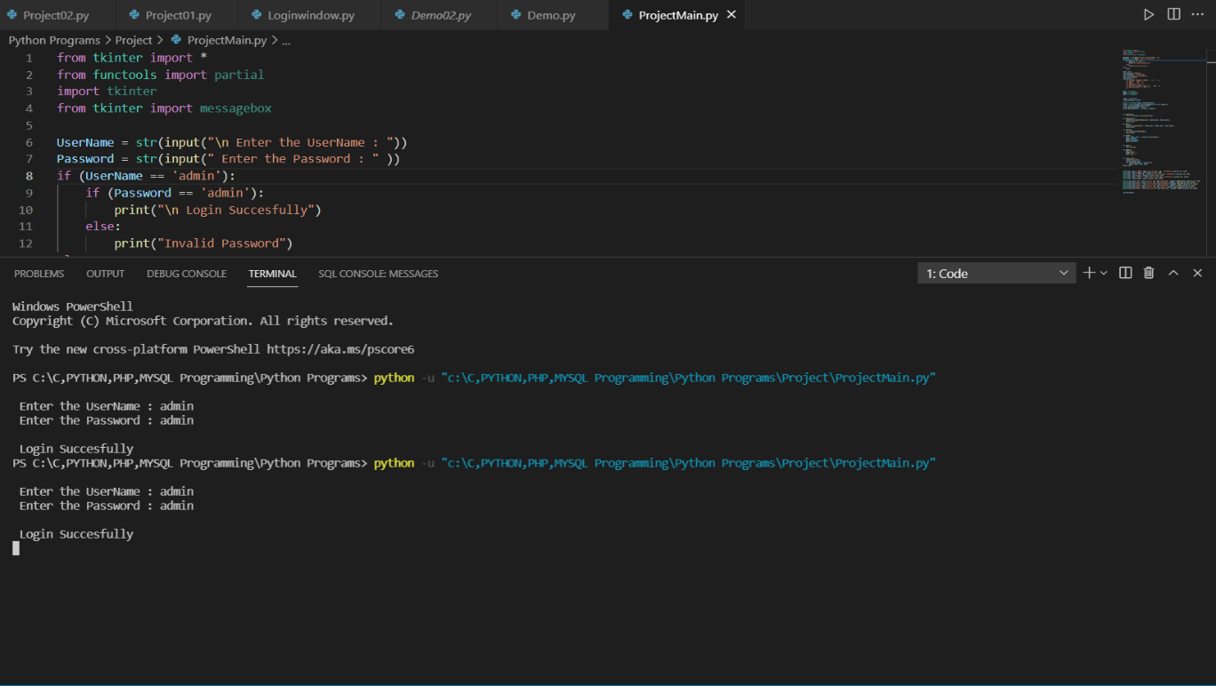

Figure 7.1 Digital Contact Book Design

**7.2Code of Digital Contact Book**

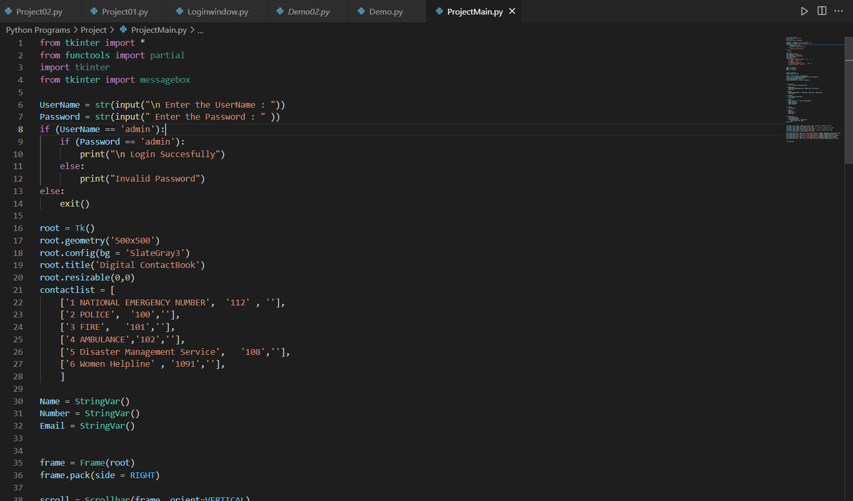

Figure 7.2 Code of Digital Contact Book

**Chapter 8**

**Conclusion**

Development of Digital Contact Book was really on eye opening experience for our team and we learned a lot from the project development. In this digital contact book project, which is based on python language we were able to add may useful features that can provide help in the real world for the user. The projects program consists of many features such has the ability for the user to add contacts and edit existing contacts. The user can also view existing contacts on the list. There are also some default emergency contacts in the list for urgent use in case of emergency. The user can resent the form fields to blank to start their next use. We took help from many project development platforms such has Udemy, Python.org, w3schools. We look Forward for future project enhancement to make our work look and feel more efficient and user friendly with more features. We are glad that we the students of parul institute of computer application got the chance to develop this project with the help of our guide ***Prof Dharmendrasinh*** Rathod who gave us the required skills and ideas to develop this project.

**Chapter 9**

**Future Enhancement**

We would like to add many more features in future such has connecting our project to the internet and add database. We would also like to polish our project and add cloud save function.

**Chapter 10**

**References**

Website:

1. <https://www.python.org/about/gettingstarted/>
2. <https://www.geeksforgeeks.org/python-tkinter-tutorial/>
3. <https://www.youtube.com/watch?v=YXPyB4XeYLA>

Book:

1. Let Us Python

-Yashwant Kanetkar